INSTITUTO INMACULADA CONCEPCION VALDIVIA
ENGLISH DEPARTMENT
Miss Carol Eckhardt I.-

ENGLISH AS A FOREIGN LANGUAGE (EFL) LEARNING HANDOUT N° 2 FOR 5TH GRADES

Name: __________________________________________________Date: March 18th, 2020

Capacity: Logical Reasoning Skills: Identify- Recognize

Contents: Unit 0 Sea Creatures

Value: Freedom Attitude: Autonomous For questions or suggestions send me an email to miss.eckhardt@hotmail.com
For new words please use this online dictionary:
Press CTRL+ CLICK
https://dictionary.cambridge.org/es/diccionario/ingles-espanol/sea

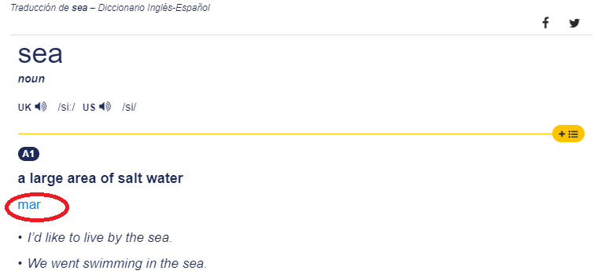

- Identify vocabulary by finding sea animals words in the puzzle, then write them in the correct picture. Work being autonomous.
- Identify vocabulary by looking at each sea animal picture and unscramble the letters and write the name of each one on the line provided. Be autonomous.
- Identify vocabulary by completing the crossword below. Be autonomous.
- Recognize specific information by reading 3 times the text below. Color a crayon each time you read, then color the turtle. Be autonomous.
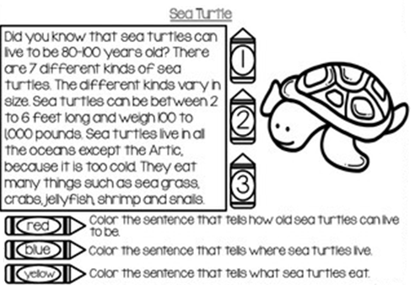
- Recognize specific information by reading the text 3 times. Color a crayon each time you read and then illustrate the passage. Work being autonomous.

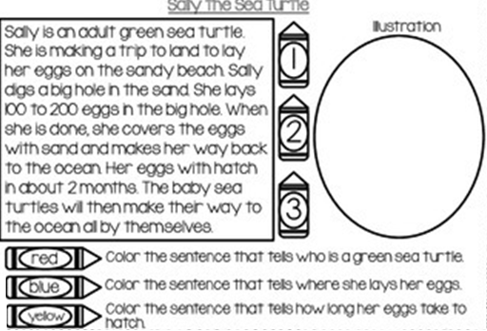

Word | Meaning
1.
2.
3.
4.
5.
Which words are new for you? List 5 of them and translate into spanish

LET’S PLAY

Check pronunciation and your knowledge by following this website:
Press CTRL+ CLICK
https://learnenglishkids.britishcouncil.org/es/category/topics/sea-animals
Play with:
Animals Water 1
Animals Water 2
LET LOVE BE THE MOTTO OF YOUR LIFE M.P.v.M

