INSTITUTO INMACULADA CONCEPCION VALDIVIA
ENGLISH DEPARTMENT
Miss Carol Eckhardt I.-

ENGLISH AS A FOREIGN LANGUAGE (EFL) LEARNING HANDOUT N° 1 FOR 6TH GRADES

Name: __________________________________________________Date: March 18th, 2020

Capacity: Logical Reasoning Skills: Recognize and Apply

Contents: Unit 1 “Food and Health”, have to, has to, do not have to and does not have to

Value: Truth Attitude: Responsibility

For questions or suggestions send me an email to miss.eckhardt@hotmail.com
For new words please use this online dictionary:
Press CTRL+ CLICK
https://dictionary.cambridge.org/es/diccionario/ingles-espanol/sea

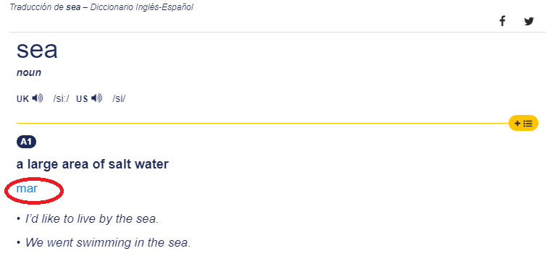

JUST TO REMEMBER WHAT WE WORKED IN CLASS
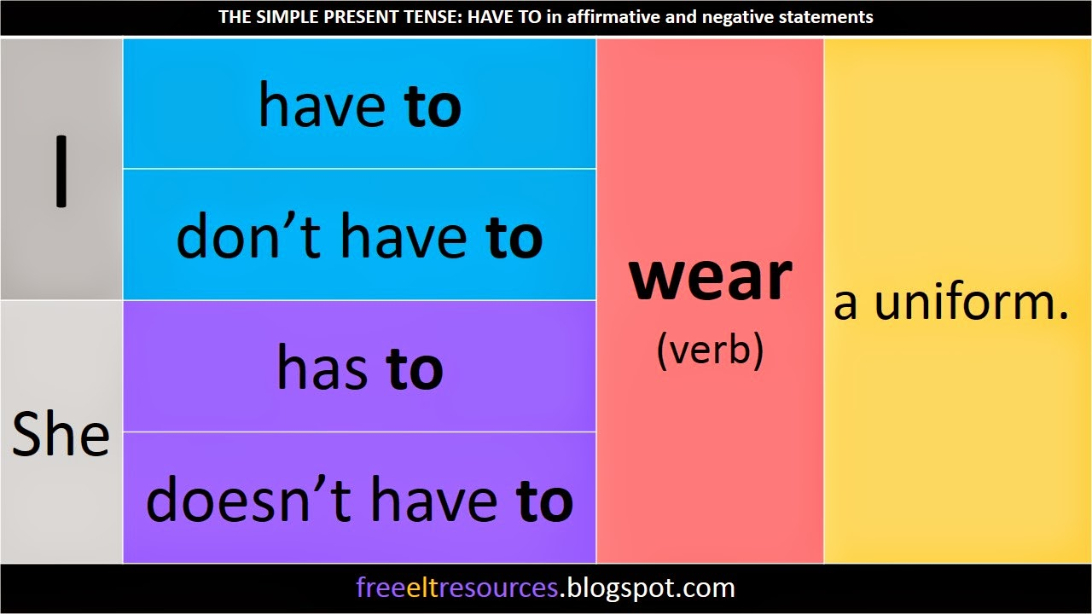

- Recognize the correct use of HAVE TO/ HAS TO by clicking the websites below. Be responsible.

Press CTRL+ CLICK
https://www.englisch-hilfen.de/en/exercises/tenses/have_to.htm

http://www.focus.olsztyn.pl/en-have-to-has-to-exercise.html#.XnGdpKgzbIU

Remember to write or print these exercises with your own answers. Please keep them in your English Copybooks.

- Recognize the correct use of DO NOT HAVE TO / DOESN’T HAVE TO by clicking the websites below. Be responsible with you own work.

https://www.englisch-hilfen.de/en/exercises/tenses/do_not_have_to.htm

https://englishgrammarexercise.com/dont-have-to-doesnt-have-to-exercise/

Remember to write or print these exercises with your own answers. Please keep them in your English Copybooks.

- Apply the use of HAVE TO/ HAS TO/ DON’T HAVE TO/DOESN’T HAVE TO by completing the sentences below. Be responsible.

Example: my mother … my mother has to finish her lunch before she leaves.
- My father…
- My mother…
- My parents
- My teacher…
- My classmates…
- My pet…
- Chile…
- Students…
- Valdivia…
- I have to…

Word | Meaning
1.
2.
3.
4.
5.
Which words are new for you? List 5 of them and translate into spanish

LET LOVE BE THE MOTTO OF YOUR LIFE M.P.v.M

