INSTITUTO INMACULADA CONCEPCION VALDIVIA
ENGLISH DEPARTMENT
Miss Carol Eckhardt I.-

ENGLISH AS A FOREIGN LANGUAGE (EFL) LEARNING HANDOUT N° 1 FOR 7TH GRADE A

Name: ________________________________________Date: March 18th, 2020

Capacity: Logical Reasoning Skills: Recognize and Apply

Contents: Unit 1 “Feelings and Opinions”, comparatives adjectives

Value: Truth Attitude: Responsibility

For questions or suggestions send me an email to miss.eckhardt@hotmail.com
For new words please use this online dictionary:
Press CTRL+ CLICK
https://dictionary.cambridge.org/es/diccionario/ingles-espanol/sea
- Recognize the comparative of each adjective by completing the crossword below. Be responsible.
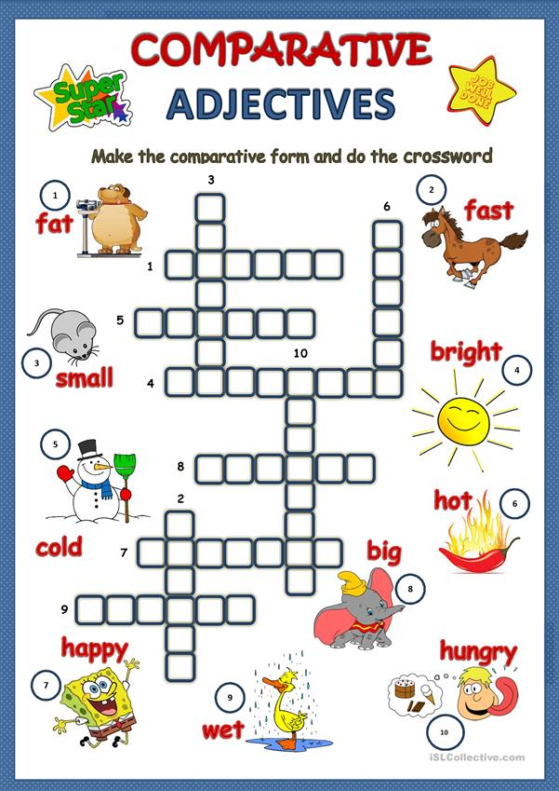
- Apply the use of comparative adjectives by doing the following exercises below. Do not forget to write or print your own answers and have them in your English copybook. Be responsible with your own work.

Press CTRL+ CLICK

https://agendaweb.org/grammar/comparative-adjectives-exercises.html

