My dear students,
We’ll continue with past simple since it is the base content for this year. You will start answering the first and second item related to REGULAR VERBS (those ending in ED) and later on continue with exercises related to IRREGULAR VERBS. To help you, I sent you a handout with a hundred verbs. If you want to be successful solving this handout, you MUST learn the them by heart. Please, take advantage of this time at home and learn irregular verbs!

INSTITUTO INMACULADA CONCEPCION VALDIVIA
ENGLISH DEPARTMENT
Miss Pamela Rebolledo Alvarez

ENGLISH AS A FOREIGN LANGUAGE (EFL) LEARNING HANDOUT U1

Name:_________________________________ Date: ___________ Grade: IB

Capacity: Logical Reasoning/ Written Expression Skills: Identify, Apply, Write

Contents: Past Simple Value: Liberty Attitude: Autonomy

I. IDENTIFY the structure PAST SIMPLE (regular verbs) and complete the following affirmative sentences with correct form of the verbs in the box. Work in this handout with AUTONOMY.

START LISTEN WATCH CLOSE WAIT

1. We ______________________ to the new Beyoncé CD.
2. The movie ______________________ at 8 o’ clock.
3. I ______________________ at the bus stop for 30 minutes.
4. The teacher ______________________ the window because it was cold.
5. My sister ______________________ TV until midnight.

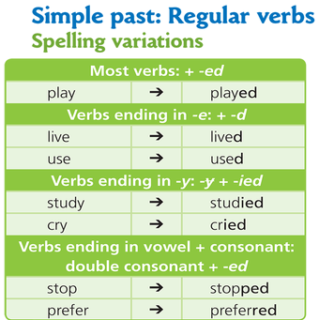

II. APPLY past simple (regular verbs) and complete the paragraphs with the verbs in the box.

ARRIVE CALL HELP STOP STUDY TALK WAIT

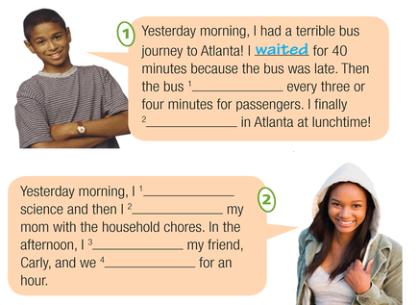

III. IDENTIFY irregular verbs and complete the affirmative sentences with the past form of the verbs in brackets.

1. Helen _____________________ (come) to my birthday party last year.
2. I _____________________ (write) three emails last night.
3. They _____________________ (read) The Joker last year.
4. They _____________________ (take) the bus to the school late.
5. I _____________________ (speak) to Matt last night.

IV. WRITE the sentences again in the negative form. There is an example at the beginning.
I saw the movie on TV
I didn’t see the movie on TV.

1. You sang that song very well.
___________________________________________________________

2. Jake went to school yesterday.
___________________________________________________________

3. Mary wore her new jeans to the party.
___________________________________________________________

4. Ana and Luis played tennis on Monday.
___________________________________________________________

5. I liked ´The Ice Age´ very much.
___________________________________________________________

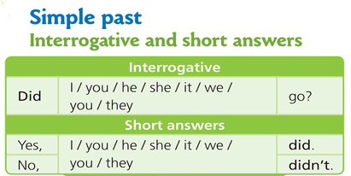

V. WRITE simple past questions and short answers according to the prompts ( or ). There are two examples at the beginning.

Bob / play tennis / yesterday?
Did Bob play tennis yesterday? () Yes, he did.

Carol and Sophia / buy fruit / on Saturday?
Did they buy fruit on Saturday? () No, they didn’t.

1. Frank / make pizza/ on the weekend? ()
_____________________________________________________________________ _________________________

2. Danny / buy a sweatshirt / on Sunday morning? ()
_____________________________________________________________________ _________________________

3. Neil and Sarah / watch a horror movie / last night. ()
_____________________________________________________________________ _________________________

4. Sofia / go / to school yesterday? ()
_____________________________________________________________________ _________________________

5. The team players / win the game? ()
_____________________________________________________________________ _________________________

IV. WRITE coherent sentences in past simple using the verbs given and the prompts.

Cut (?)__________________________________________________________________________________________
Read () _________________________________________________________________________
Buy ()__________________________________________________________________________________________
Spit (?)__________________________________________________________________________________________
Burst (?)__________________________________________________________________________________________
Sleep () _________________________________________________________________________
Forget () ________________________________________________________________________________________
Ride (?) __________________________________________________________________________________________
Understand () ____________________________________________________________________
Write () _________________________________________________________________________
Leave () _________________________________________________________________________
Lose () _________________________________________________________________________

