English Worksheet- 1st Grade

CAP: Logical Reasoning
DES: Recognize - Discover
CONTENTS: Starter (0) Unit- Numbers – Family members.
VALUE: Faith
ATTITUDE: Autonomy – Joy.

Recognize numbers, by matching with the correct picture, then colour and sing along developing autonomy

https://www.youtube.com/watch?v=DR-cfDsHCGA

Discover Family members, by listening to the song ( hipervinculo) , then make the puppet family, working with joy

https://www.youtube.com/watch?v=hqr46XZhtRg

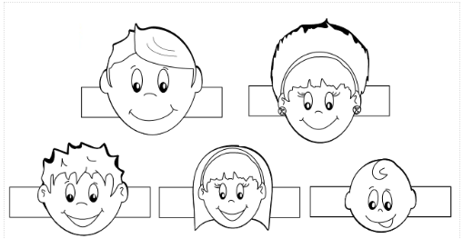

COLOR CUT

Questions? E-mail me! miss.amy.inmaculada@gmail.com
I´ll be answering from 7:40 to 14:00 from Monday to Friday.

