Objectives:
Capacity: Logical Reasoning.
Skill: apply, recognize
Contents: Comparatives & Superlative Adjectives. Subject Pronouns, Object Pronouns and Possessive Adjectives.
Value: Responsibility Attitude: autonomy

Feel free to ask questions at: ximealevera@gmail.com

ENGLISH AS A FO EIGN LANGUAGE (EFL)

8° Básico B
Student: Date: March 17th 2020

Instructions:
- First read the visual explanation and examples carefully.
- Use Dictionary to check new vocabulary.
- Illegible answers and omission will be considered a wrong answer.
- You MUST answer with pen and avoid the use of liquid paper.
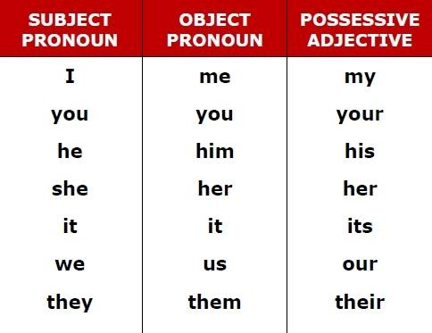
APPLY Possessive Adjectives by filling in the blanks below to complete the sentences. Use the Possessive Adjective in the above box
- Where is classroom? We can’t find it.
- Susan, is that pen on the table?
- A: What is name? B: My name is Thomas.
- I think this is book. She dropped it on the floor.
- names are Kevin and Stewart. They are my friends.
- He forgot to write name on the test!
- A: What is your phone number? B: phone number is 555-9826.
- Did the cat eat all of food?
- The children are crying because they can’t find toys.
- Mariam and Jennifer like new teacher.

APPLY Object Pronouns and Subject Pronouns by replacing the underlined words with the appropriate pronouns in the box. Use capital letters when necessary.
she her him it we us they them

- I saw Mr. Brown this morning and gave Mr. Brown my homework.
- John likes computer games but he doesn’t play computer games very often.
- Neil Armstrong was born in 1930. Neil Armstrong landed on the moon in 1969.
- Penguins don’t live near the North Pole. Penguins live near the South Pole.
- My aunt lives in Toronto but my aunt often comes to visit my family and me.

- If you have your ticket, you can give your ticket to that man over there.
- First, my friend and I went shopping. Later, my friend and I went home.
- Where was Sarah? I didn’t see Sarah at the party last week.
- John is a really nice guy. I like John a lot.
- The planet Mars has two moons. The two moons are both very small.

II. APPLY adjectives by matching with the opposites.

- good a expensive
- nice b boring
- cheap c bad
- popular d small
- interesting e unpopular
- big f difficult
- easy g horrible

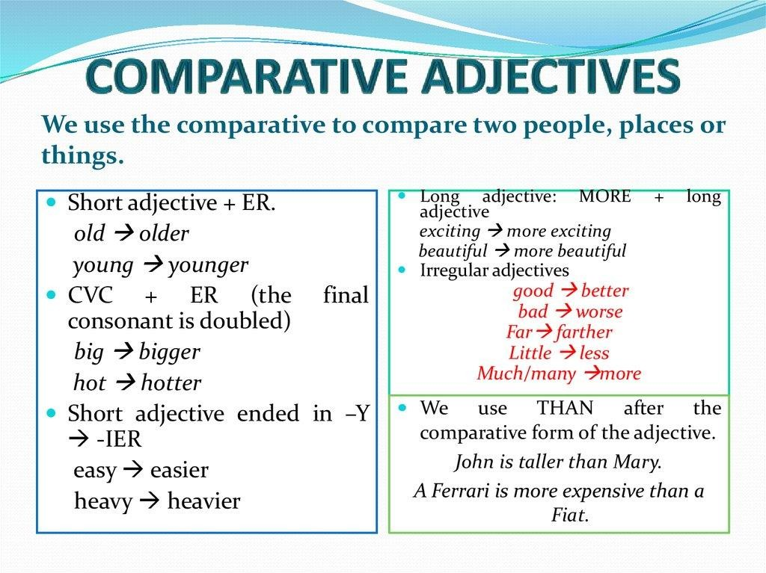

RECOGNIZE Comparative and Superlatives by choosing the correct words.
What is the faster / fastest animal in the world?
- I can swim furthest / further than Tom.
- Sam is more artistic / the most artistic person in his family.
- Whales are bigger / the biggest mammals.
- Todd is funnier / the funniest than Ela!
- This is the best / better café in town.

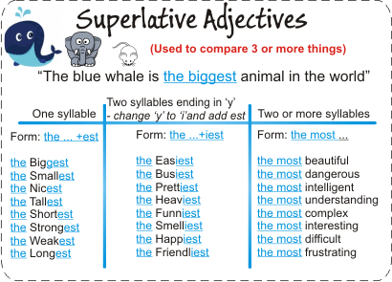

APPLY comparative or superlative form of the adjective by completing the sentences using the given adjective.
- Cats are than mice. (intelligent).
- I am the girl here. (tall)
- Lions are than dogs. (big)
- Falcons are the birds. (fast)
- What is the animal? (aggressive)
- I am at swimming than my sister. (good)

APPLY the comparative or superlative form of the adjectives by completing the sentences.
- Elephants are slow and horses are fast. Horses are .
- All the children are quieter than Sarah.
Sarah is child.

- I’m not very good at painting, but my sister is. My sister is .
- Lisa got the highest mark in the exam. Lisa is student.
- Everyone is better than me at sport.
I am at sport.
- I can swim 500 metres. Tom can swim 1,000 metres. Tom can swim .

