Objectives:
Capacity: Logical Reasoning.
Skill: apply , infer, recognize
Contents: Past Simple (+), negative (-) and questions (?) Reading Comprehension and Irregular Verbs.
Value: Responsibility Attitude: Autonomy

Feel free to ask questions at: ximealevera@gmail.com

ENGLISH AS A FO EIGN LANGUAGE (EFL)
I° Medio A
Student: Date: March 17th 2020

Instructions:
- First read the visual explanation and examples carefully.
- Use Dictionary to check new vocabulary.
- Illegible answers and omission will be considered a wrong answer.
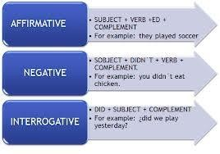
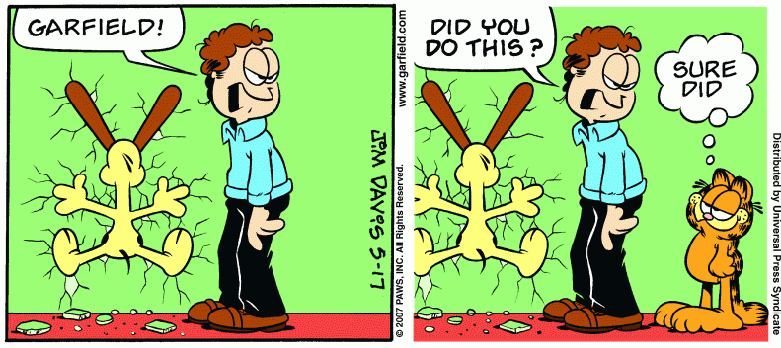
- You MUST answer with pen and avoid the use of liquid paper.

APPLY Past Tense by choosing the correct verbs.
- Vincent Van Gogh was / were a famous artist.
- Copernicus and Albert Einstein was / were famous scientists.
- Marilyn Monroe and Audrey Hepburn wasn’t / weren’t famous sportspeople.
- Pelé wasn’t / weren’t a famous swimmer.
- Was / Were the Wright brothers the inventors of the aeroplane?

APPLY Past Simple affirmative form of the verbs by completing the sentences.
They had a child last year. (have)
- We football yesterday. (play)
- I in Rome when I was five. (live)
- He his exams last year. (pass)
- My parents a flat in London. (buy)
- She a doctor last year. (become)

APPLY negative past simple sentences by choosing the correct words to make
I didn’t liked / like the film.
- We don’t / didn’t enjoy the film yesterday.
- She didn’t bought / buy any new shoes.
- We didn’t went / go to the cinema last night.
- The film don’t / didn’t start at eight o’clock.
- He didn’t get / got married when he was young.

Read aloud the text and then give it a tittle.

Tittle: ‘ ’

Becky was visiting Aunt Agatha at her house at the beach. It was a beautiful summer day. Becky had built a giant sand castle that morning. Aunt Agatha took pictures of the castle to send to Becky’s parents. It was a great big sand castle. Later that morning, Becky and Aunt Agatha went swimming in the ocean. It was fun to jump with the waves. Then, they went in the house and ate sandwiches and strawberries for lunch.
Becky wanted to play on the beach that afternoon. Aunt Agatha told her it was too hot to go outside without a hat on. Becky didn’t have a hat. Aunt Agatha told her not to worry, she could wear one of hers. Becky tried on four hats. The pink one was really pretty, but it had a big bow in the back that was too long for Becky. The green hat was too fancy for Becky. She did not like that hat at all. The blue hat was nice, but it had an ugly bird on it. Then, Becky saw a big brown hat with a yellow ribbon on it. That hat was made of straw. It was a perfect hat for the beach. It was too big for Becky’s head but she didn’t care. It was a great hat.

INFER the following questions
- Where was Becky?
  - at the store
  - at the beach
  - at school
  - at home

Who was Becky visiting?
  - her Grandparents
  - her friends
  - her sister
  - her Aunt Agatha

Why didn’t Becky like the blue hat?
  - it was too fancy
  - it was new
  - it had an ugly bird on it
  - it was old

Why didn’t Becky want to wear the pink hat?
  - the bow was too long
  - it had a flower
  - it had a bird on it
  - it was dirty

Why did Aunt Agatha want Becky to wear a hat?
- it was raining
- it was too hot
- it was cold
- it was snowing

Why did Becky like the brown
hat?
- it was ugly
- it was perfect
- it was too big
- it was cold

Instituto Inmaculada Concepción Departamento de Inglés Profesora Ximena Vera M.

RECOGNIZE Past Tense of the irregular verbs by completing the following chart

Infinitive | Past | Write 7 sentences using the past tense
1. PAY - |  | 1.
2. RUN - |  | 2.
3. SELL - |  | 3.
4. SHINE - |  | 4.
5. SHOW - |  | 5.
6. WEAR - |  | 6.
7. WIN - |  | 7.

Infinitive | Past | Write 7 sentences using the past tense
1. LEAVE - |  | 1.
2. LOSE- |  | 2.
3. TEACH - |  | 3.
4. BE - |  | 4.
5. HIDE - |  | 5.
6. FIND - |  | 6.
7. TAKE- |  | 7.

Infinitive | Past | Write 7 sentences using the past tense
1. KNOW - |  | 1.
2. UNDERSTAND - |  | 2.
3. MEET - |  | 3.
4. SIT - |  | 4.
5. SPEND - |  | 5.
6. BECOME - |  | 6.
7. BUILD - |  | 7.

3

