English Worksheet- 4th Grade

CAP: Logical Reasoning – Oral production
DES: Identify – Verbal fluency
CONTENTS: Starter (0) Unit- Dates.

1) Identify information from the song, by completing the lyrics with the words given. Work with autonomy

2) Apply vocabulary, by completing the Birthday chart, developing perseverance.

3) Practice Fluency, by singing along. Invite your family to sing with you with joy!

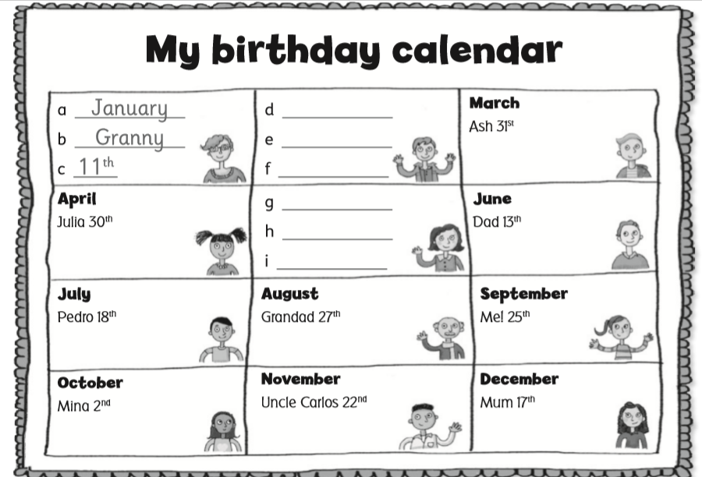

Questions? E-mail me! miss.amy.inmaculada@gmail.com
I´ll be answering from 7:40 to 14:00 from Monday to Friday. xoxo

