English Worksheet- 8th Grade

CAP: Logical Reasoning – Written expression
DES: Recognize – Identify – Manage vocabulary
CONTENTS: Starter (0) Unit- School subjects.

Recognize School Subjects, by finding the words. Work with perseverance

Questions? E-mail me! miss.amy.inmaculada@gmail.com
I´ll be answering from 7:40 to 14:00 from Monday to Friday. Xoxo

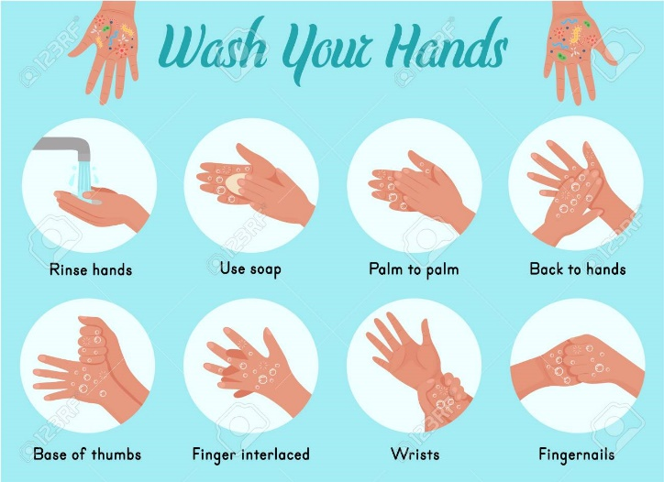

And please, don’t forget

Identify vocabulary, by completing the text with the words given. Work with autonomy

Manage vocabulary, by writing a short text about your favourite subject, explain why do like about. Work with autonomy.

_______________________________________________________________________________________________________________________________________________________________________________________________________________________________________________________________________________________________________________________________________________________________________________________________________________________________________________________________________________________________________________________________________________________________________________________

Love you!
Miss Amy

