**I know the weather!**

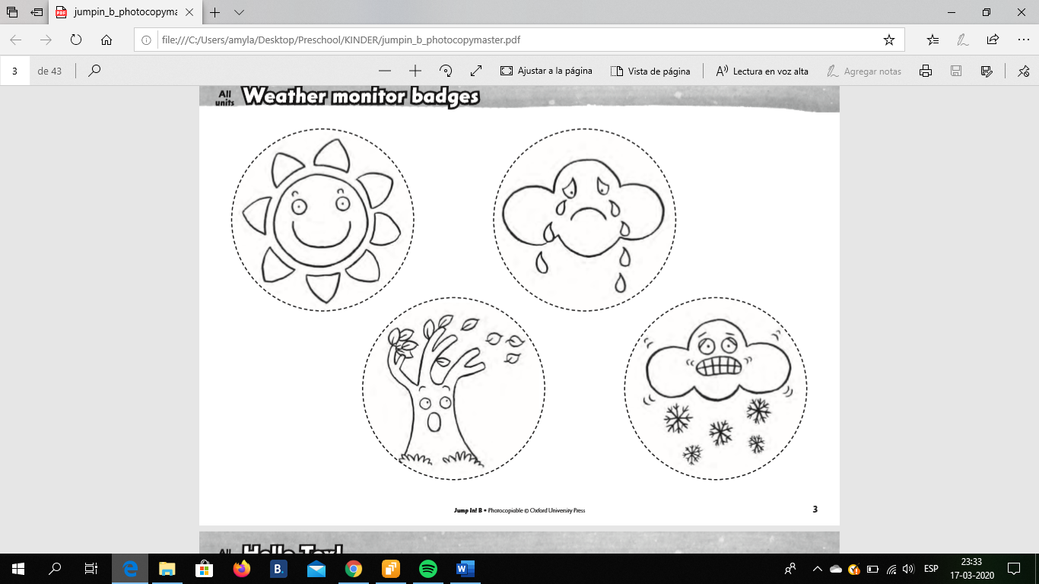

Sunny

Rainy

Snowy

Windy