My dear students,
We’ll start our year with First Conditional which is the combination of present simple and will.
I know you’ve seen present simple before; however, it’s never late to revise previous contents since you will have to manage present simple to answer this handout. If you want to remember the structure, go to these links: https://www.youtube.com/watch?v=FWJRwasIWnM
https://www.youtube.com/watch?v=L9AWrJnhsRI

I’ll also send you the list of verbs you have to learn this year. Please, take advantage of this quarantine period and study the verbs, you won’t regret it! Pinky promise

INSTITUTO INMACULADA CONCEPCION VALDIVIA
ENGLISH DEPARTMENT
Miss Pamela Rebolledo A.

ENGLISH AS A FOREIGN LANGUAGE LEARNING HANDOUT Unit 1

Name: _____________________________________ Grade: Date: IV A-B

Capacity: Written Expression / L. Reasoning Skills: Write/ Apply / Identify

Contents: First Conditional Value: Liberty Attitude: Autonomy
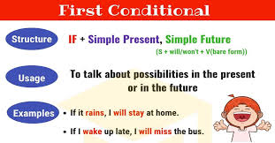

1) IDENTIFY first conditional and match the sentences’ halves.

1. I’ll be disappointed if you don’t come to the party.
If you eat too much, I’ll be disappointed

if it doesn’t rain tomorrow I’ll be happy

if I pass my final exam you’ll feel unwell

I’ll phone you If you pay for dinner,
We’ll go to the park if I need your help,
I’ll pay for lunch if you don’t come to the party

2.____________________________________________
____________________________________________
3.____________________________________________
____________________________________________
4.____________________________________________
____________________________________________
5.____________________________________________
____________________________________________
6.____________________________________________
____________________________________________

2) RECOGNIZE first conditional structure and decide if the sentences are well written or not.

1. If I find the book you want, I’ll send you a text message.
a) correct b) incorrect

2. If the tickets were too expensive, Sam won’t buy them.
a) correct b) incorrect

3. I’ll tell Jane the news if she come to the party.
a) correct b) incorrect

4. John’s parents will give him a car if he passes the exam.
a) correct b) incorrect

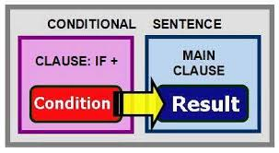

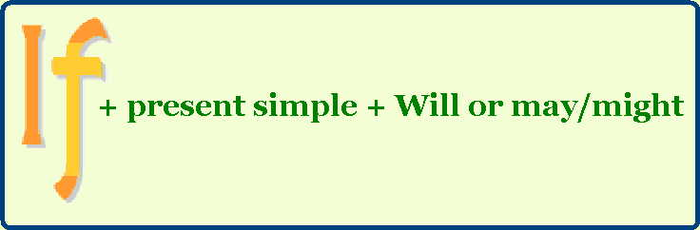

3) APPLY the first conditional structure and complete the sentences.

1. I’ll be happy ____________________________________________________________________________
2. If it rains all weekend, ____________________________________________________________________
3. If I forget my best friend’s birthday, _____________________________________________________
4. I’ll pass all my exams _____________________________________________________________________
5. If I don’t feel well tomorrow morning, ____________________________________________________
6. I’ll go to bed early ________________________________________________________________________
7. I’ll be disappointed _______________________________________________________________________

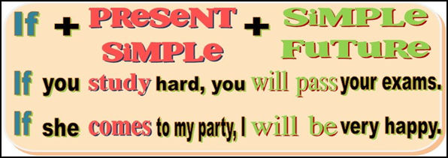

4) WRITE superstitions using First Conditional structure.

1. If a cat ______________ (wash) behind its ears, it ______________ (rain).
2. If the bride ___________ (make) her own dress, it_________________ (bring) bad luck.
3. You ______________ (catch) a cold if a cat _____________ (sneeze) three times.
4. If you ____________ (open) an umbrella indoors, it ____________ (bring) bad luck.
5. Something bad _________________ (happen) to you if you ____________ (walk) under a ladder.
6. If you ________ (take) the last piece of bread on the plate, you ____________ (be) unlucky.
7. If you ___________ (have) an itchy nose, you ______________ (have) an argument with someone soon.

5. WRITE sentences using the structure of First Conditional and the following verbs:

Foretell _________________________________________________________________________________________

Light _________________________________________________________________________________________

Seek _________________________________________________________________________________________

Teach _________________________________________________________________________________________

Weep _________________________________________________________________________________________

Burn _________________________________________________________________________________________

Feed _________________________________________________________________________________________

