INSTITUTO INMACULADA CONCEPCION VALDIVIA
ENGLISH DEPARTMENT
Miss Carol Eckhardt / Miss Ximena Vera

ENGLISH AS A FOREIGN LANGUAGE LEARNING HANDOUT unit 1

“‘I will strive to impregnate my whole day of a gentle joy’ (MPvM)
Instructions:
- First read the visual explanation and examples carefully.
- Use Dictionary to check new vocabulary.
https://dictionary.cambridge.org/es-LA/dictionary/english/oxford
- Take your time to work, do not hurry up.

Name: _____________________________________ Grade: 7 básico A-B Date: April 2020

Capacity: Logical Reasoning / Written Expression /

Skills: Identify / Write

Content: There is / There isn’t / There are / There aren’t

Value: Liberty

Attitude: Autonomy

- IDENTIFY There is / There are by completing the following sentences working with AUTONOMY.

- IDENTIFY positive and negative sentences by answering the questions.

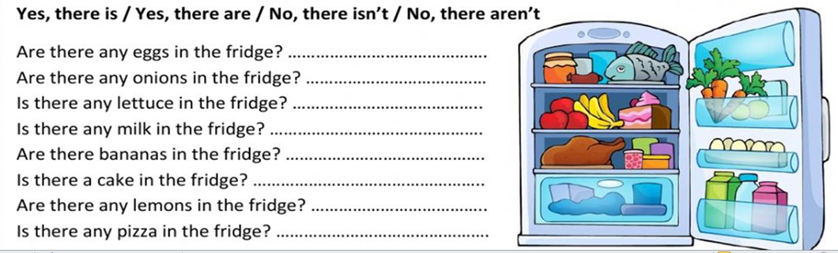

- IDENTIFY There is/There are by looking at the pictures and choosing a face.

- WRITE sentences with There is/ There isn’t/ There are/ There aren’t. Five sentences each using the picture below.

THERE IS
________________________________________________________________________________________________________________________________________________________________________________________________________________________________________________________________________________________________________________________________________________________________________________________________________________________________________________________

THERE ISN’T
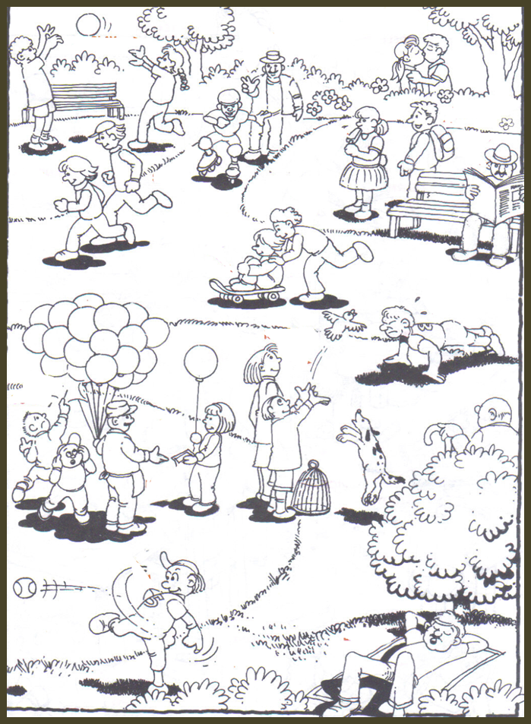
________________________________________________________________________________________________________________________________________________________________________________________________________________________________________________________________________________________________________________________________________________________________________________________________________________________________________________________
THERE ARE
__________________________________________________________________________________________________________________________________________________________________________________________________________________________________________________________________________________________________________________________________________________________________________________________________________________________________________________________________________________________________________
THERE AREN’T
__________________________________________________________________________________________________________________________________________________________________________________________________________________________________________________________________________________________________________________________________________________________________________________________________________________________________________________________________________________________________________

