

**INSTITUTO INMACULADA CONCEPCION VALDIVIA**

**ENGLISH DEPARTMENT**

**Miss Pamela Rebolledo / Miss Ximena Vera**

**ENGLISH AS A FOREIGN LANGUAGE LEARNING HANDOUT unit 1**

*“Let love be the motto of your life” (MPvM)*

**Name:** _____________________________________ **Grade:** I medio A-B **Date**: _____________

Capacity: Logical Reasoning / Written Expression / Analyze

Skills: Identify / Compare / Write

Content: Used to

Value: Liberty

Attitude: Autonomy

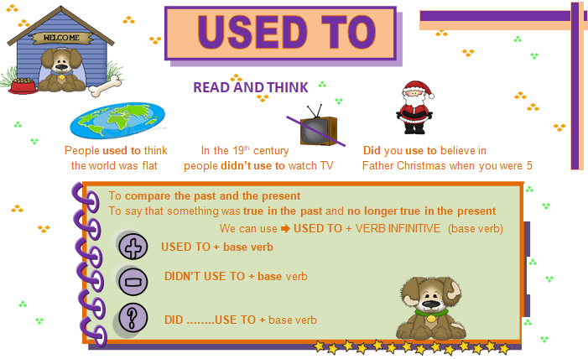

**EXERCISE 1: IDENTIFY the structure ‘used to’ in order to complete the sentences developing AUTONOMY. There is an example given.**

1. When I was a baby, I ( wear nappies ) When I was a baby, I used to wear nappies
2. When she was a little girl, my grandmother ( not have ) TV………………………..…………………….
3. A long time ago, children ( not go ) to school by bus …………………………………………………….
4. Dad, where ( you / live ) before you got married ? ………………………………………….…………….

**EXERCISE 2: COMPARE the way of life of the Inuit in the past with their way of life today.**

[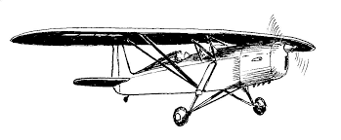](http://images.google.com/imgres?imgurl=http://latvianaviation.com/Clip%20Art/019.jpg&imgrefurl=http://latvianaviation.com/ClipArt.html&usg=__aZKW9-q5Eq8na8X1KDaNXCyfa2M=&h=510&w=1232&sz=74&hl=fr&start=0&zoom=1&tbnid=Z95nhddHRAySEM:&tbnh=51&tbnw=124&prev=/images?q%3Dfloatplane%2Bclipart%26hl%3Dfr%26sa%3DG%26biw%3D1020%26bih%3D484%26tbs%3Disch:1&itbs=1&iact=hc&vpx=593&vpy=85&dur=4508&hovh=144&hovw=349&tx=187&ty=77&ei=f5sfTYSUJ8ay8gPvz6CBBw&oei=f5sfTYSUJ8ay8gPvz6CBBw&esq=1&page=1&ndsp=18&ved=1t:429,r:4,s:0)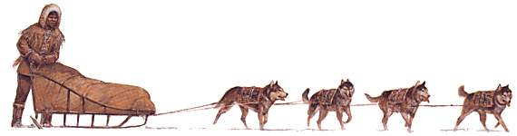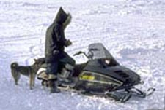The Inuit used to be called “Eskimos”. What did the Inuit use to do? Use the information and the verbs below to create sentences using USED TO. There is an example given.

[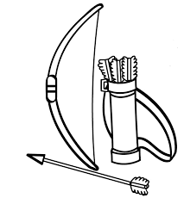](http://images.google.com/imgres?imgurl=http://ldsfiles.com/clipart/data/media/53/archery.jpg&imgrefurl=http://ldsfiles.com/clipart/img-bows-and-arrows-364.htm&usg=__sWtP_saQMTVOq0OaP6vqH-Mu6NM=&h=802&w=720&sz=92&hl=fr&start=128&zoom=1&tbnid=mDr8dwSrCaRoQM:&tbnh=153&tbnw=117&prev=/images?q%3Darrows%2Bclipart%26hl%3Dfr%26biw%3D1020%26bih%3D484%26tbs%3Disch:1&itbs=1&iact=hc&vpx=277&vpy=141&dur=951&hovh=237&hovw=213&tx=147&ty=144&ei=JJsfTYf9B9GQ4Qba-bmGAg&oei=D5sfTcDpGYOg8QOnoZyFBw&esq=14&page=13&ndsp=10&ved=1t:429,r:6,s:128)

[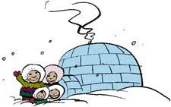](http://images.google.com/imgres?imgurl=http://www1.free-clipart.net/gallery2/clipart/Architecture_And_Landmarks/Igloo_3.jpg&imgrefurl=http://www1.free-clipart.net/cgi-bin/clipart/directory.cgi?direct%3Dclipart/Architecture_And_Landmarks%26img%3D36&usg=__CnMUGK18eFbbFmoXP_h1dQlfGTY=&h=141&w=225&sz=8&hl=fr&start=24&zoom=1&tbnid=KkCoJhP5sWAh_M:&tbnh=112&tbnw=180&prev=/images?q%3Digloos%2Bclipart%26hl%3Dfr%26sa%3DG%26biw%3D1020%26bih%3D484%26tbs%3Disch:1&itbs=1&iact=hc&vpx=784&vpy=155&dur=2075&hovh=112&hovw=180&tx=72&ty=91&ei=A5wfTaX1IMaw4AaU5qCGAg&oei=tZsfTffmF9Cs8QPer4CEBw&esq=16&page=3&ndsp=8&ved=1t:429,r:3,s:24)

*Travel by*

*Live*

*Get light from*

*~~Travel by~~*

*Hunt caribous with*

1. Oil lamps / Electric light bulbs

2. Kayaks / floatplanes

3. Igloos and tents / modern houses

4. Arrows / rifles

~~5. Dogsled / snowmobile~~

[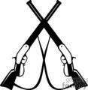](http://images.google.com/imgres?imgurl=http://www.graphicsfactory.com/clip-art/image_files/tn_image/1/1297041-tn_cowboy_14-10262006.jpg&imgrefurl=http://www.graphicsfactory.com/search/rifles_P1.html&usg=___vSLdXytMVjgg0MF21BlrDjGOxs=&h=120&w=117&sz=6&hl=fr&start=18&zoom=1&tbnid=w_V1JrdAYd5hTM:&tbnh=96&tbnw=93&prev=/images?q%3Drifle%2Bclipart%26hl%3Dfr%26sa%3DG%26biw%3D1020%26bih%3D484%26tbs%3Disch:1&itbs=1&iact=hc&vpx=817&vpy=194&dur=1045&hovh=96&hovw=93&tx=66&ty=86&ei=VJsfTcngEZmU4gab_sSMBw&oei=S5sfTa_eJIiW8QO7qoCGBw&esq=2&page=2&ndsp=8&ved=1t:429,r:7,s:18)

*example:* ***In the past*** *, the Inuit* ***used to*** *travel by dogsled.* ***Now****, they* ***travel by snowmobile***

1. ……………………………………………………………………………………………………………………….
2. ……………………………………………………………………………………………………………………….
3. ……………………………………………………………………………………………………………………….
4. ……………………………………………………………………………………………………………………….

**EXERCISE 3: WRITE sentences using USED TO. You must reorder the words to complete the sentences.**

1, a lot – my – when – used to – was – he – father – smoke – a teenager

……………………………………………………………………………………………………………………….

2. younger – did – she – when – she – holidays – use to – spend – her – was – in the countryside - **?**

……………………………………………………………………………………………………………………….

3 .instead – to watch TV – in those days – read – people – they – used to – didn’t use

……………………………………………………………………………………………………………………….

**EXERCISE 4: WRITE sentences using the structure ‘USED TO’ to complete them with the verbs from the box. Then write the number of the sentences with the appropriate picture working with AUTONOMY.**

**CLIMB DECORATE EAT FISH FLY GO (x3) HAVE LOOK MAKE (x2) RIDE SHOVEL**

**USED TO**

1. Lulu ___________________________________ cakes.
2. Benny and Lulu ______________________ snowmen.
3. Benny and Lulu _________________________ the Christmas tree.
4. Benny ________________________________ his kite.
5. Lulu ___________________________________ skiing.
6. Benny ________________________________ his bike.
7. Benny and Lulu _______________________ snowball fights.
8. Benny ______________________________ the snow.
9. Benny and Lulu ____________________ in the frozen lake.
10. Benny and Lulu ______________________ ice-skating.
11. Benny and Lulu _______________________ to the roof of their house and count the snowflakes.
12. Benny __________________________ snowboarding.
13. Benny and Lulu _____________________ at the stars.
14. Benny and Lulu ____________________ sausages and hot dogs.

**Answer the questions.**

1. Did Benny use to ride his motorbike? _____________
2. Did Lulu use to make cookies? ___________________
3. Did Lulu and Benny use to make snowmen? ________
4. Did Benny use to go snowboarding? ______________
5. Did Benny and Lulu use to count the stars? _________
6. Did Benny and Lulu use to eat sausages and hot dogs? ____________________
7. Did Benny use to fly his kite? ____________________
8. Did Lulu use to go swimming? ___________________
9. Did Lulu and Benny use to have snowball fights? _______________________
10. Did Lulu and Benny use to fish in the sea? _________________

