INSTITUTO INMACULADA CONCEPCION VALDIVIA
ENGLISH DEPARTMENT
Miss Ximena Vera

ENGLISH AS A FOREIGN LANGUAGE LEARNING HANDOUT unit 1

“‘I will strive to impregnate my whole day of a gentle joy’ (MPvM)
Instructions:
- First read the visual explanation and examples carefully.
- Use Dictionary to check new vocabulary.
https://dictionary.cambridge.org/es-LA/dictionary/english/oxford
- Use Irregular Verbs Handout to study them.
- Take your time to work do not rush.

Name: _____________________________________ Grade: III Medio A-B Date: April 2020

Capacity: Logical Reasoning / Written Expression /

Skills: Identify / Write

Content: Present Perfect: positive, negative and questions.

Value: Liberty

Attitude: Autonomy
Present Perfect: Look at these examples:
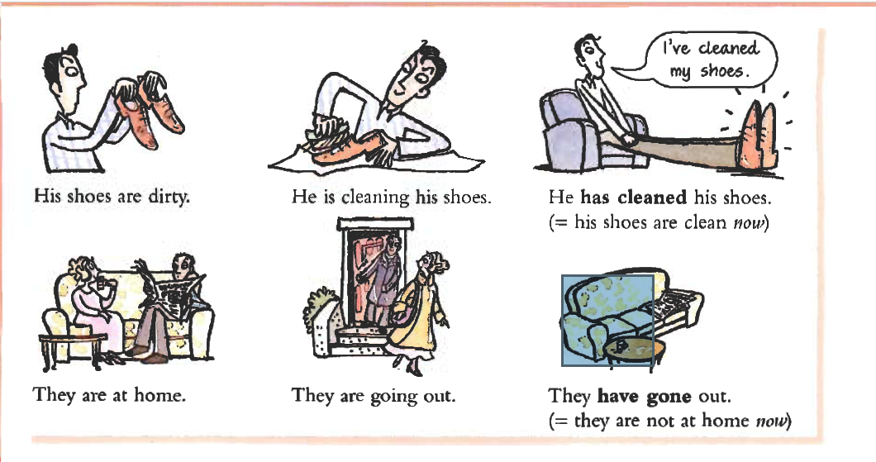

.

We USE the Present Perfect for an action in the past with a result now.

- WRITE Present Perfect sentences choosing the phrases from the box to match them with the images. There is an example at the beginning. Work with AUTONOMY.
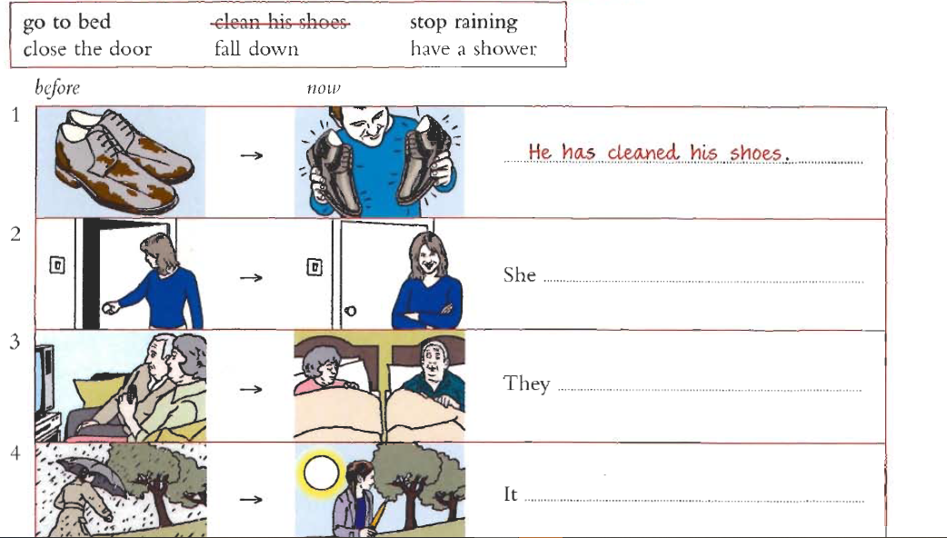

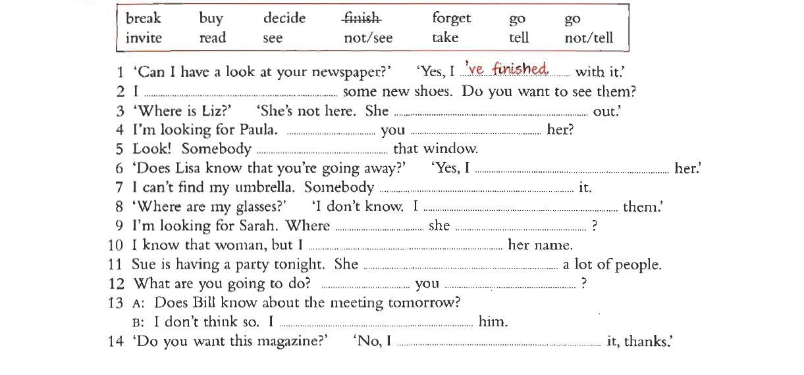
- IDENTIFY Present Perfect by completing the sentences with a verb from the box.

- IDENTIFY all the examples of Present Perfect by highlighting its structure.

- WRITE answers to the questions using the given structure of Present Perfect.

Have we learned any lesson as humanity with this coronavirus crisis?

_________________________________________________________________________________________________________________________________________________________________________________________________________________________________________________________________________________________________________________________________________________________________________________________________________________________________________________________________________________________________________________________________________________________________________

What have you done during these days of quarantine?
__________________________________________________________________________________________________________________________________________________________________________________________________________________________________________________________________________________________________________________________________________________________________________________________________________________________________________________________________________________________

