English Worksheet- 2nd Handout
3rd Grade

CAP: Logical Reasoning / Oral Expression
DES: Discover – Recognize – Practice ponunciation
CONTENTS: Starter unit – Descriptive words
VALUE: Freedom.
ATTITUDE: Listening attitude- perseverance – autonomy

Trabajar directamente en el libro, si no lo tiene imprimir esta hoja. Los audios correspondientes los encuentra en la página web, junto a las guías, con el nombre que aparece en el hipervínculo.

Let’s learn descriptive words!
Discover descriptive words, by listening to Tom, work with listening attitude

Practice pronunciation by listening and repeating, developing perseverance.
Who is Tom talking about? Can you identify the person he’s describing?

Recognize descriptive words, by matching the pictures, with the correct word. (you can play “memory game”, and then glue the cards). Work with perseverance

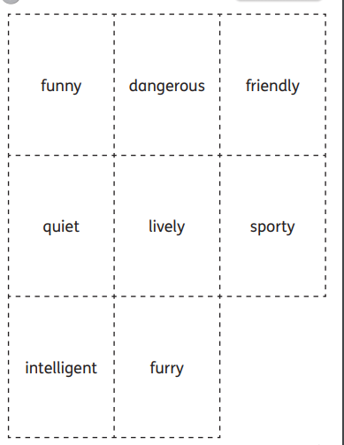
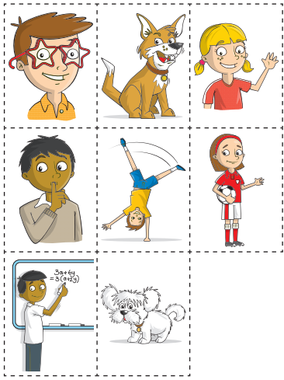

2. Recognize descriptive words, by completing the crosswords, you can use the cards to help you write the words. Wok with autonomy

Questions? E-mail me! miss.amy.inmaculada@gmail.com
I´ll be waiting for your comments, questions and doubts 😊

