English Worksheet n° 2
4th Grade

CAP: Logical Reasoning
DES: Identify – Recognize – Apply
CONTENTS: Starter (0) Unit- Dates.
VALUE: Faith- Freedom
ATTITUDE: Perseverance – Autonomy

DATES!
(Fechas)
We are learning how to say and write dates. It’s important to know the months and ordinal numbers. Let’s start with months from January to December.
1. Identify months of the year, by singing the song, then complete the wordsearch. Work with perseverance and autonomy

https://www.youtube.com/watch?v=Fe9bnYRzFvk https://www.youtube.com/watch?v=v608v42dKeI
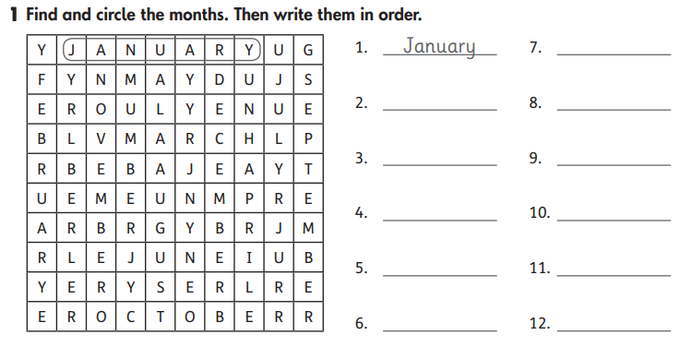

Now, let’s work with ordinal numbers!

REMEMBER! Ordinal numbers are called this way because they give an order to things
IN SPANISH: Los números ordinales dan un orden a las cosas. Como cuando jugamos o hacemos una carrera y decimos:” ¡Llegue primero! Tu segundo y Pepito tercero”. Esos son los números ordinales. En Ingles, usamos estos números para decir las fechas. Y se dicen así:

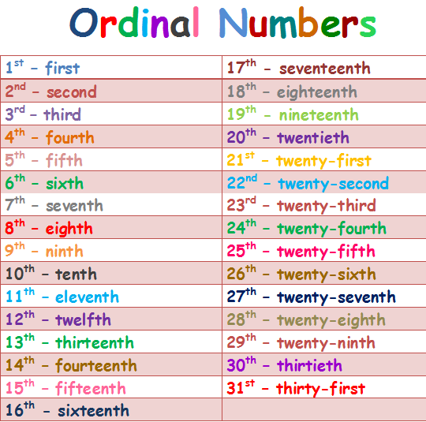

Now, let’s practice! .

2. Recognize ordinal numbers, by writing the correct letters to each one. Work with perseverance
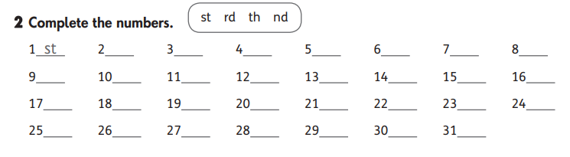

3. Apply ordinal numbers and months of the year, by writing the dates marked on the calendar, developing perseverance
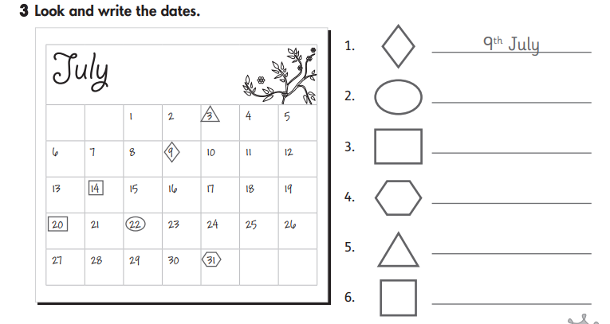

Questions? E-mail me! miss.amy.inmaculada@gmail.com
I´ll be answering your mails from Monday to Friday. 😊

