English Study Worksheet- 8th Grade

CAP: Logical Reasoning – Written expression
DES: Apply – Manage vocabulary
CONTENTS: Present continuous.
VALUE: Freedom - Faith
ATTITUDE: Autonomy – Perseverance

Remember!
We use Present continuous to express that something is happening now, while we’re speaking.

Warm up exercise.
Can you tell what’s happening right now in this picture? FUN FACT!
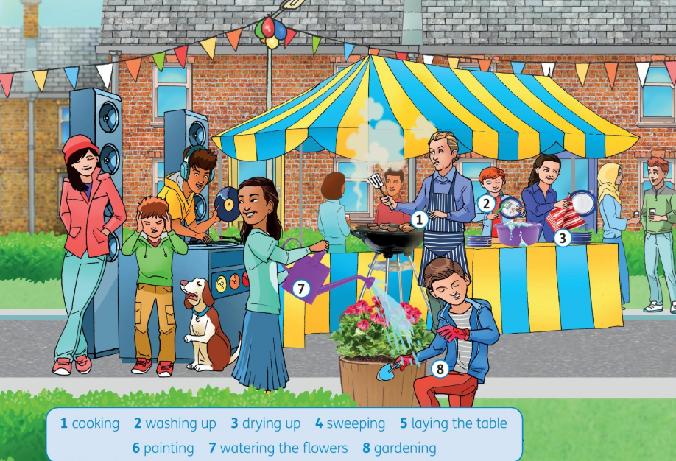
STREET PARTIES ARE COMMON IN U.K.
FOR MORE INFORMATION FOLLOW THE FOLLOWIN LINK:
https://www.streetparty.org.uk/history-of-street-parties/

Manage vocabulary, by writing sentences according to the picture, developing perseverance
EX: 1. The man on the blue apron is cooking burgers. Can you write more sentences?
2. The boy at the back, is washing the dishes
3.
4.
5.
If you could write the sentences in the previous exercises, it means you were paying attention in class ( Yay!!!! ) If you couldn’t, here’s something to help you out!

Present Continuous – Forms

- We make the affirmative form of the present continuous with the verb be and the -ing form of the verb.
I’m looking at my English dictionary.
Chris is speaking to the teacher.
We’re learning about life in China.
You’re doing a difficult science question.
- To make the negative form, use the verb be plus not and the -ing form in both the affirmative and the negative.
In spoken or informal written English, we use short forms in both the affirmative and the negative.
I’m not reading the notes.
He isn’t listening to his friend.
They aren’t doing their homework.

- To make the question form, invert the verb be and the
-ing form.
Am I sitting here?
Is Alex playing football?
Are you checking the answer to that question? What are we studying?
Where are those students going?
- We make short answers with the verb be only, without the -ing form.
Are you learning Mandarin? No, I’m not.
Is Selin doing an exam? Yes, she is.
Are they finishing their homework? No, they aren’t.

SPELLING RULES

- With the majority of verbs: add -ing. watch → watching check → checking play → playing eat → eating

- With verbs that end in -e: remove -e and add -ing. revise → revising have → having
move → moving make → making

- With verbs that end in vowel + single consonant:
double the consonant and add -ing.
sit → sitting swim → swimming run → running get up → getting up

LET’S PRACTICE!
1. Apply spelling rules for PRESENT CONTINUOUS, by writing the following verbs, developing autonomy

SWIM: SIT: FLY:
DRINK : PRACTICE: MAKE:
RUN: SURVIVE: REPEAT

SPEAK: DANCE: EAT:

LOOK: WRITE: DRAW:

2. Apply present continuous by writing sentences using the words given according to the images, developing perseverance
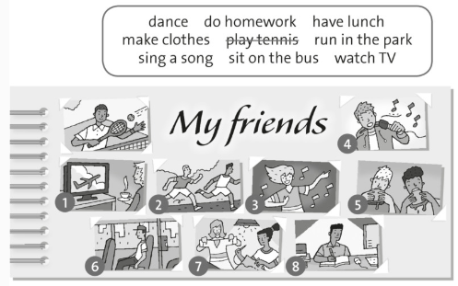

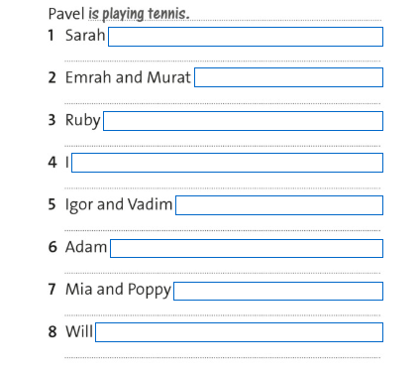

3. Apply Present continuous, by writing affirmative and negative sentences, using the words given, work with autonomy

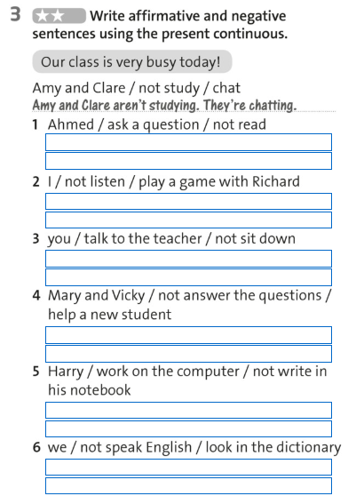

4. Apply Present continuous (questions and answers) by writing using the words given, according to the pictures. Work with perseverance
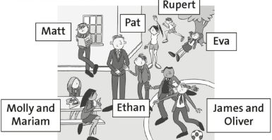

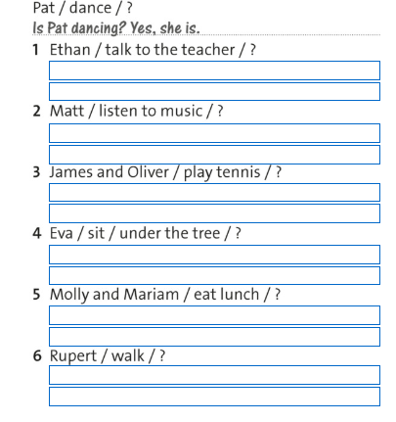

5. Manage vocabulary, by writing a short text about what you are doing write now, and what’s happening around you. Work with perseverance

For example:
I’m writing on my computer, I’m not watching TV, I’m listening to Rock&Pop station. My cat is under the table playing with my feet and my stomach is asking for food…I’m starving! ☹

WELL DONE!
NOW YOU ROCK USING PRESENT CONTINUOUS! 😉

https://www.perfect-english-grammar.com/present-continuous-exercise-1.html

https://elt.oup.com/student/solutions/elementary/grammar/grammar_04_012e?cc=cl&selLanguage=en
EXTRA ON LINE PRACTICE

Questions? E-mail us!
ximealevera@gmail.com (8°B)
miss.amy.inmaculada@gmail.com (8°A)
We’ll be waiting for your worksheets back!!

And please, don’t forget

