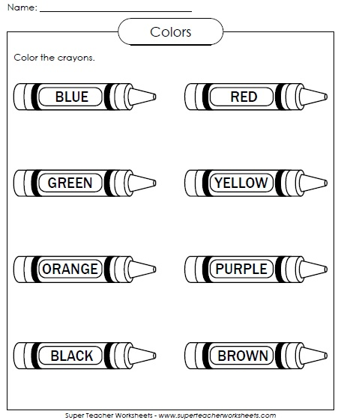

S

OO

OO

RRR

L

C

**I know my …**

Identify colors from the instructions. Working with perseverance. <https://www.youtube.com/watch?v=jYAWf8Y91hA>

My name is:___________ My class:___________

[miss.amy.inmaculada@gmail.com](mailto:miss.amy.inmaculada@gmail.com) ( for doubts or comments 😊 )